Cyclistic

bike share analysis report

by Darko Brajičić

Junior Data Analyst

Introduction

In 2016, Cyclistic launched a successful bike-share offering. Since then, the program has grown to a fleet of 5,824 bicycles that are geotracked and locked into a network of 692 stations across Chicago. The bikes can be unlocked from one station and returned to any other station in the system anytime.

Until now, Cyclistic’s marketing strategy relied on building general awareness and appealing to broad consumer segments. One approach that helped make these things possible was the flexibility of its pricing plans: single-ride passes, full-day passes, and annual memberships. Customers who purchase single-ride or full-day passes are referred to as casual riders. Customers who purchase annual memberships are Cyclistic members.

Cyclistic’s finance analysts have concluded that annual members are much more profitable than casual riders. Although the pricing flexibility helps Cyclistic attract more customers, Moreno believes that maximizing the number of annual members will be key to future growth. Rather than creating a marketing campaign that targets all-new customers, Moreno believes there is a very good chance to convert casual riders into members. She notes that casual riders are already aware of the Cyclistic program and have chosen Cyclistic for their mobility needs.

Moreno has set a clear goal: Design marketing strategies aimed at converting casual riders into annual members. In order to do that, however, the marketing analyst team needs to better understand how annual members and casual riders differ why casual riders would buy a membership, and how digital media could affect their marketing tactics. Moreno and her team are interested in analyzing the Cyclistic historical bike trip data to identify trends

Ask

Three questions will guide the future marketing program:

1. How do annual members and casual riders use Cyclistic bikes differently?

2. Why would casual riders buy Cyclistic annual memberships?

3. How can Cyclistic use digital media to influence casual riders to become members?

Moreno has assigned me the first question to answer: **How do annual members and casual riders use Cyclistic bikes differently?**

Are The Data ROCCC?

|  |  |  |
| --- | --- | --- |
| Reliable | Yes | It has more than 5 million rows of data. |
| Original | Yes | Based on the background story, the data are a primary source. |
| Comprehensive | Yes | It is comprehensive, but some values are missing. |
| Current | Yes | The data is updated every month. |
| Cited | Yes | Data has been made available by Motivate International Inc. under this license. |

Analysis

All data for analysis can be downloaded [here](https://divvy-tripdata.s3.amazonaws.com/index.html). I downloaded data from the last twelve months, i.e. from 1 November 2020 to 31 October 2021.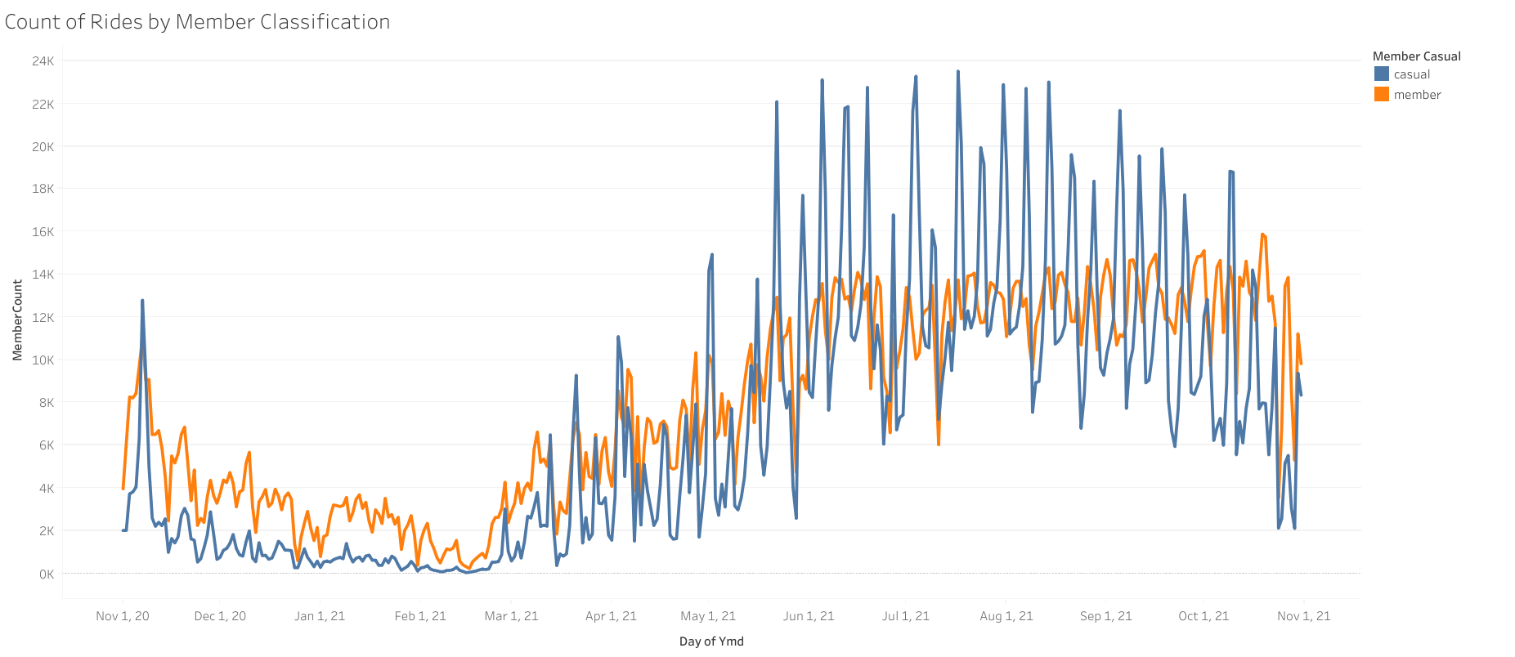

[Click to view the full interactive viz in Tableau](https://public.tableau.com/views/Cyclistic-MemberType/MemberType?:language=en-US&:retry=yes&:display_count=n&:origin=viz_share_link)

In the following analysis, we see the number of userss over a twelve-month period. The total number of users is 5,378,834, of which 2,908,317 are "Members" and 2,470,517 are "Casual" users. On the chart, we see peaks related to "Casual" drivers, and if we look in detail at the "viz" in Tableau, we will see that these peaks are Friday, Saturday, or Sunday, which indicates that "Casual" users take more rides on weekends, which will confirm graph below.

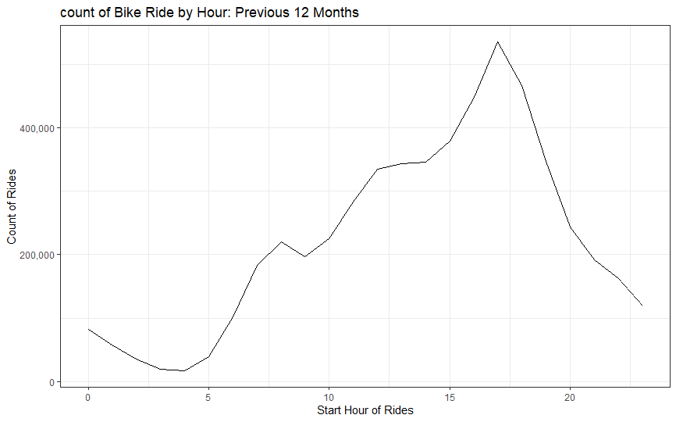

You can find the R code and ggplot on GitHub [here](https://github.com/darkob-code).

It can be seen here that most rides take place in the afternoon around 5 pm. The graph below will show us the relationship between “Members” and “Casual” riders.

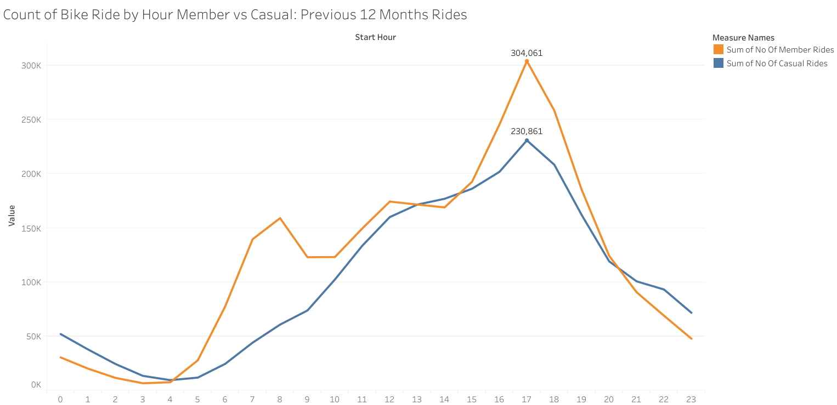

[Click to view the full interactive viz in Tableau](https://public.tableau.com/views/Cyclistic-countofBikeRidebyHourMembervsCasualNov2020-Oct2021/Sheet3?:language=en-US&publish=yes&:display_count=n&:origin=viz_share_link)

We can notice that the "Members" have two peaks, around 7.30 in the morning and around 17 in the afternoon. This time is peak, so we can conclude that the users of "Members" are mostly business people.

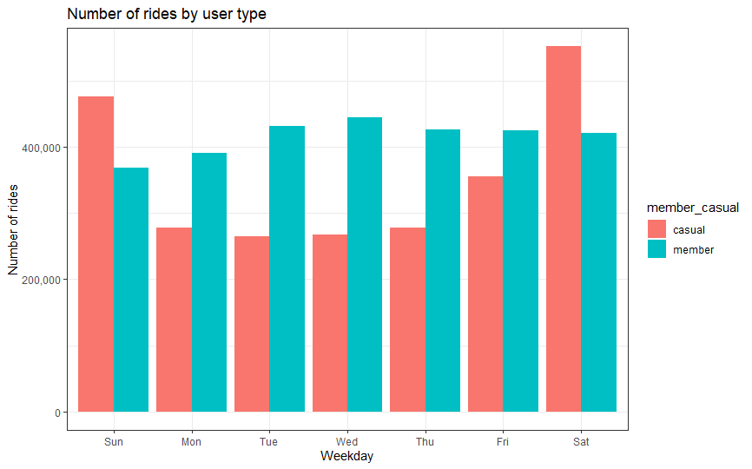

Casual customers take the most rides of the weekends. Member customers take the most rides during the week. You can find the R code and ggplot on GitHub [here](https://github.com/darkob-code).

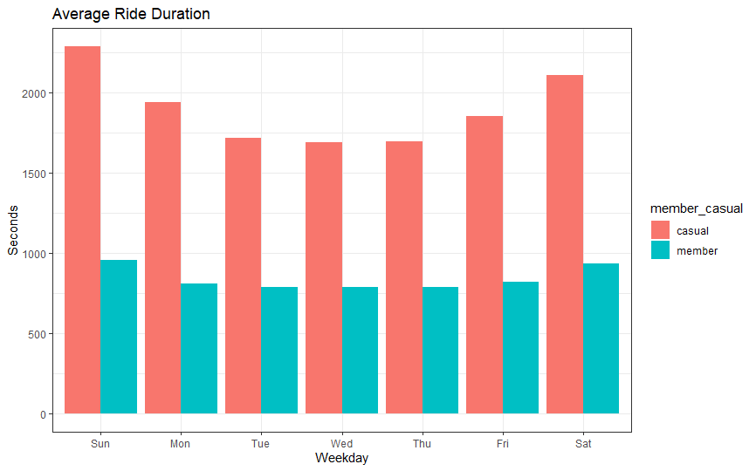

On average, members take shorter rides than casual customers. You can find the R code and ggplot on GitHub [here](https://github.com/darkob-code).

Top 20 stations by Casual User

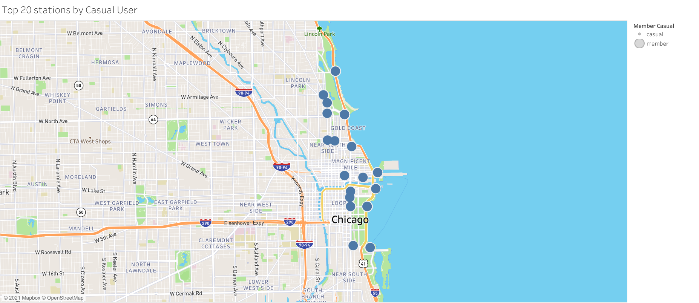

[Click to view the full interactive viz in Tableau](https://public.tableau.com/views/Cyclistic-Top20stationsbyCasualUser/Top20stationsbyCasualUser?:language=en-US&publish=yes&:display_count=n&:origin=viz_share_link)

1 Streeter Dr & Grand Ave 65022

2 Millennium Park 33331

3 Michigan Ave & Oak St 29988

4 Shedd Aquarium 22521

5 Theater on the Lake 21856

6 Lake Shore Dr & Monroe St 21385

7 Wells St & Concord Ln 19635

8 Clark St & Lincoln Ave 16983

9 Indiana Ave & Roosevelt Rd 16840

10 Wells St & Elm St 16460

11 Clark St & Elm St 16405

12 Clark St & Armitage Ave 16175

13 Wabash Ave & Grand Ave 16020

14 Lake Shore Dr & North Blvd 15639

15 Dusable Harbor 15127

16 New St & Illinois St 15121

17 Michigan Ave & Lake St 14651

18 DuSable Lake Shore Dr & North Blvd 14241

19 Michigan Ave & Washington St 14221

20 DuSable Lake Shore Dr & Monroe St 14029

The top 20 station visit by casual riders mostly are tourist locations.

Top 20 stations by Casual User

1 Clark St & Elm St 24309

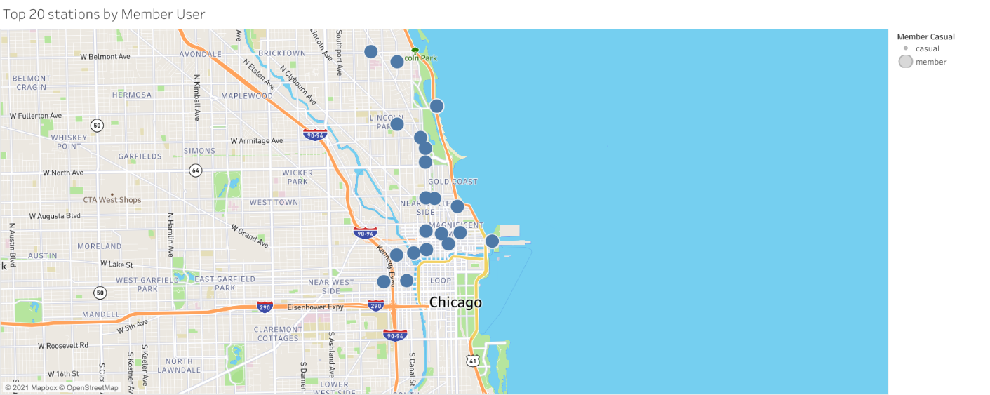

[Click to view the full interactive viz in Tableau](https://public.tableau.com/views/Cyclistic-Top20stationsbyMemberUser/Top20stationsbyCasualUser?:language=en-US&publish=yes&:display_count=n&:origin=viz_share_link)

2 Wells St & Concord Ln 22868

3 Kingsbury St & Kinzie St 21896

4 Wells St & Elm St 20249

5 Dearborn St & Erie St 19118

6 Wells St & Huron St 18609

7 St. Clair St & Erie St 18299

8 Broadway & Barry Ave 17854

9 Clark St & Armitage Ave 16676

10 Desplaines St & Kinzie St 16280

11 Clark St & Lincoln Ave 16182

12 Theater on the Lake 16160

13 Wabash Ave & Grand Ave 16149

14 Streeter Dr & Grand Ave 16101

15 Clinton St & Madison St 15627

16 Green St & Madison St 15194

17 Larrabee St & Webster Ave 14759

18 Michigan Ave & Oak St 14593

19 Wilton Ave & Belmont Ave 14445

20 Wells St & Hubbard St 14321

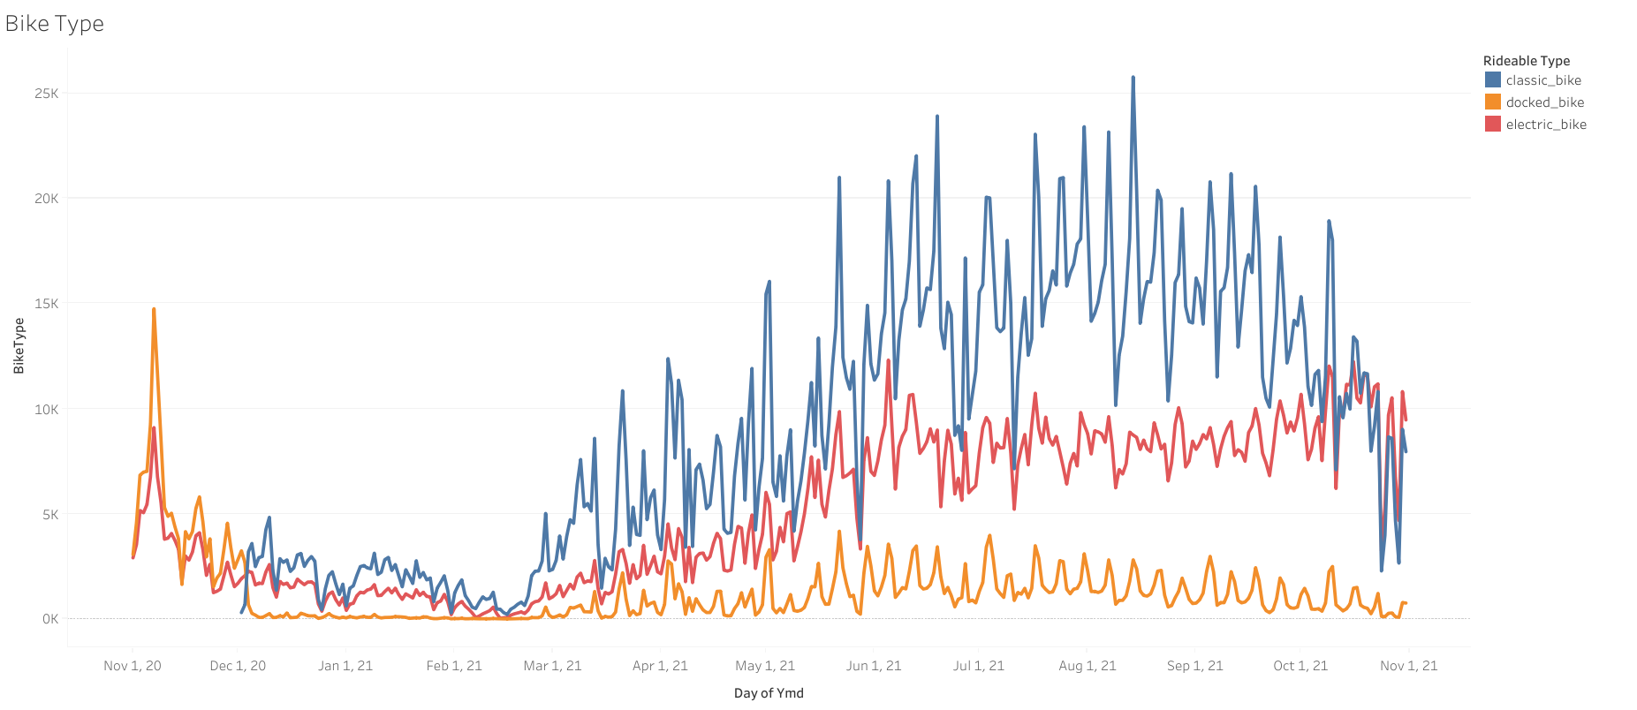

[Click to view the full interactive viz in Tableau](https://public.tableau.com/views/Cyclistic-BikeType/BikeType?:language=en-US&:display_count=n&:origin=viz_share_link)

“Classic Bikes” was introduced by December 2020. These insights indicate that “Classic Bikes” were more popular over the months and more users tend to choose “Classic Bikes” over the “Docked Bikes” and “Electric Bikes”.

Summary

The total trip count and total trip duration for casual riders and annual members are affected by the season. During the winter fewer people will opt for cycling, more often they will take public transport.

Over the years, we see a significant divergence of total trip duration from May to September for two groups of users. This has shown their usage pattern significantly due to their preference and it is clear when we look into total trip duration on every single hour within the day.

The annual member display two peak periods which is at 7.30 a.m and 5 p.m indicate they are most likely office workers. The casual rider peak period is 5 p.m. The top 20 station visit by casual riders mostly are tourist locations, the casual riders most likely are a couple, students, retirees, tourists, etc.

Recommendations

Implement a new annual membership tier at a lower price point where a total number of rides are allotted for a given time period (e.g. week, month), versus current annual membership structure (unlimited number of rides, 45-min. limit per ride), and given that on average, casual riders spend more time on their rides than current members.

Consider different price strategies like seasonal passes to increase the conversion rate.

Implement a limited time promotion for annual membership with no or less limits on Friday, Saturday, Sunday rides, because those are the most popular days casual riders use Cyclistic bikes.

The use of electric bicycles is on the rise, so it would be recommended to purchase more electric bicycles.